**Exercise 1:**

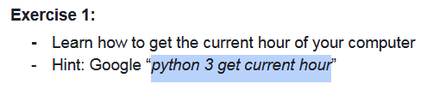

**Trả lời:**

+ File current_time.py

@@@@@@@@@@@@@@@@@@@@@@

**Exercise 2:**

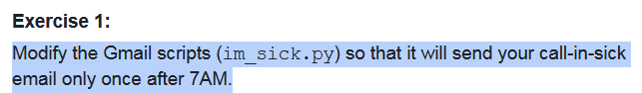

**Trả lời:**

+ File im_sick.py

@@@@@@@@@@@@@@@@@@@@@@

**Exercise 3:**

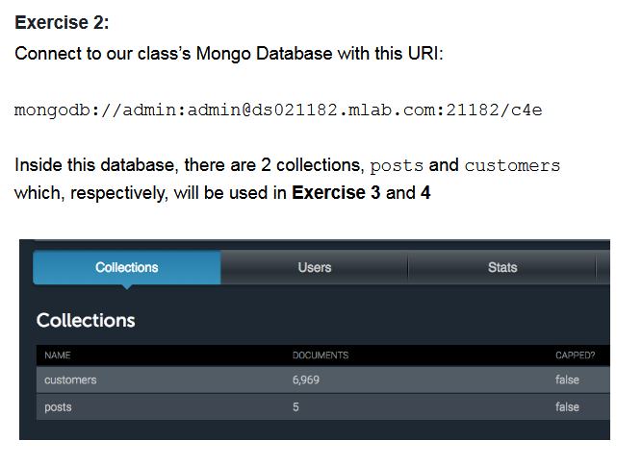

**Trả lời:**

+ File ex1.py

@@@@@@@@@@@@@@@@@@@@@@

**Exercise 4:**

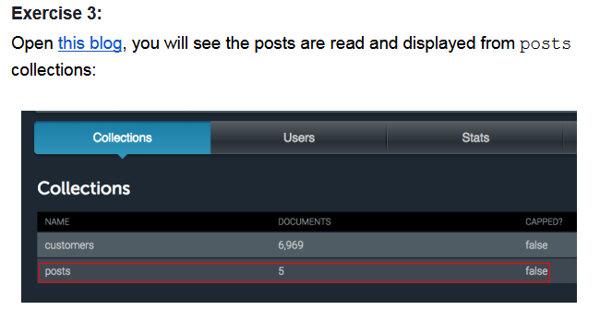

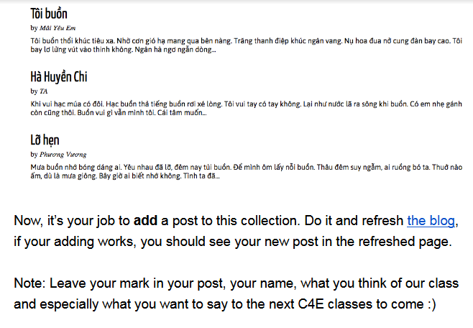

**Trả lời:**

+ File ex2.py

@@@@@@@@@@@@@@@@@@@@@@

**Exercise 5:**

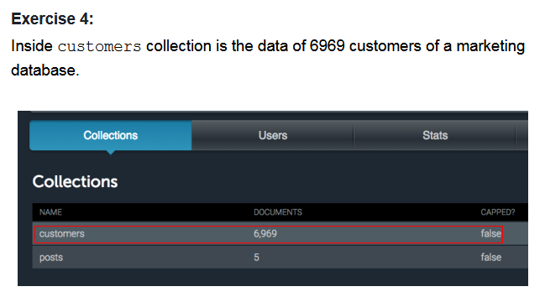

It includes name, age, address and especially refs (references)

- where the customers are acquired from: events held by the organization, advertisements or word of mouth.

- Count the number of customers group by refs

- Use MatPlotLib to draw a pie chart showing how much percentage of each reference

**Trả lời:**

+ File ex3.py